Supplementary Material
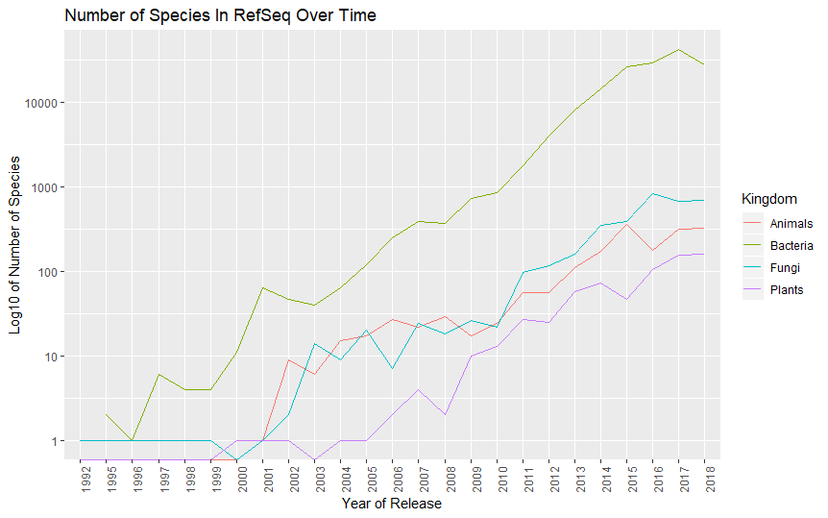
Supplementary Figure 1. The number of species present in the NCBI RefSeq database has grown roughly exponentially over time. Note that the y-axis is plotted on a log scale. Data were retrieved from the RefSeq database (47): https://ftp.ncbi.nlm.nih.gov/genomes/GENOME_REPORTS/eukaryotes.txt and https://ftp.ncbi.nlm.nih.gov/genomes/GENOME_REPORTS/prokaryotes.txt
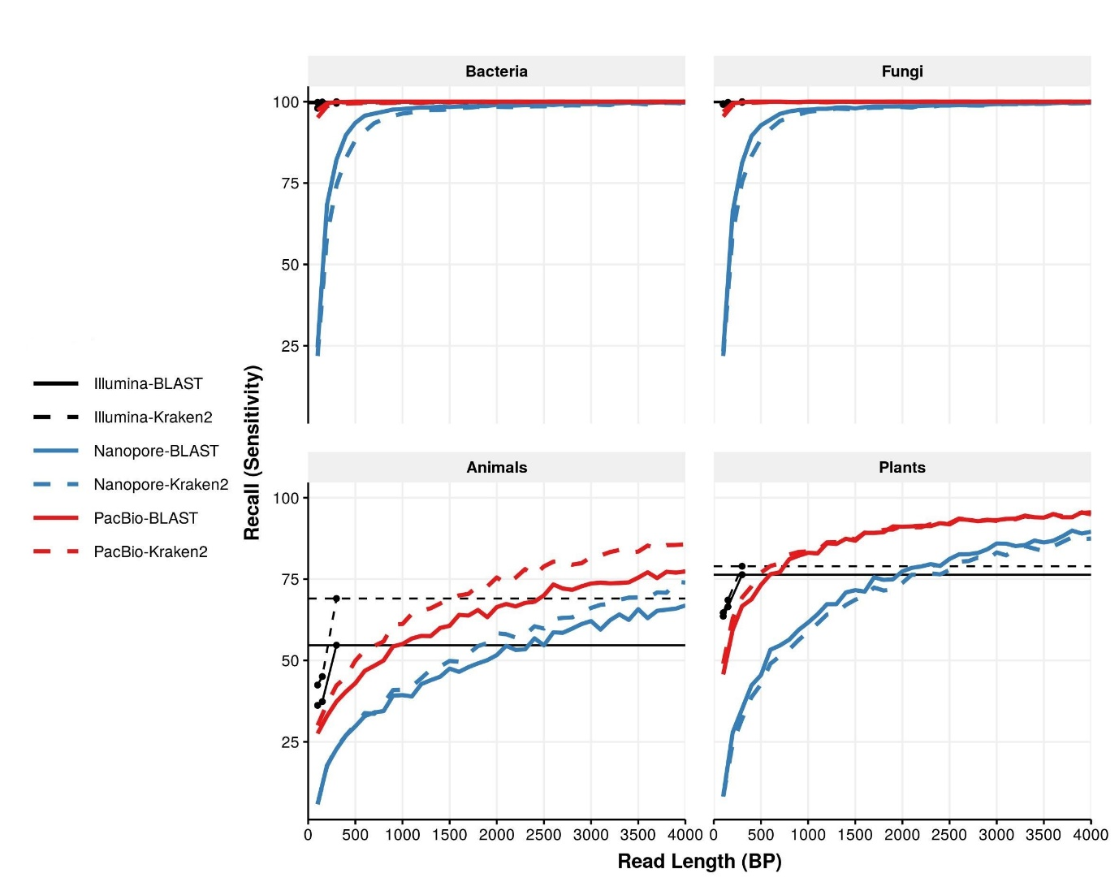
Supplementary Figure 2 Recall at the family level. Each panel shows recall for the different kingdoms. Median recall at the family level is indicated by blue lines for Nanopore or red lines for PacBio, either dashed (Kraken2) or solid (BLAST). The recall rates for 300 bp Illumina reads are shown as thin solid black lines, again either dashed (Kraken2) or solid (BLAST). Black points show the recall for all Illumina reads of all lengths (100 bp, 150 bp, and 300 bp).
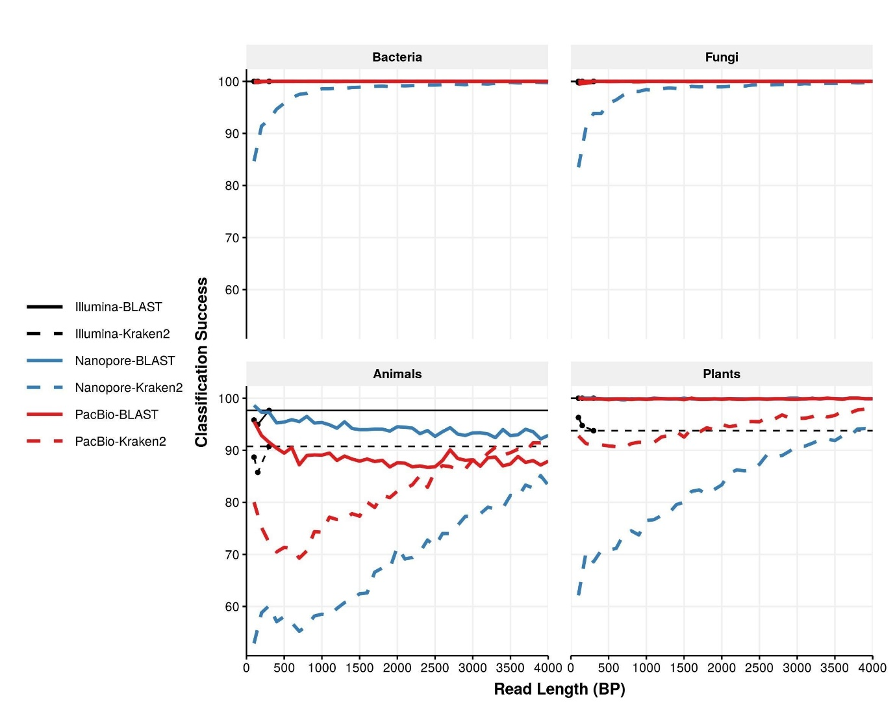
Supplementary Figure 3 Classification success at the family level. Each panel shows classification success for the different kingdoms. Median classification success at the family level is indicated by blue lines for Nanopore or red lines for PacBio, either dashed (Kraken2) or solid (BLAST). The recall rates for 300 bp Illumina reads are shown as thin solid black lines, again either dashed (Kraken2) or solid (BLAST). Black points show the classification success for all Illumina reads of all lengths (100 bp, 150 bp, and 300 bp). For animals and plants, the classification success of Kraken2 depends strongly on read length, and only surpasses BLAST in PacBio at approximately 3600bp.

Supplementary Table 1. List of species include in the in silico mock community, with associated Kingdom and NCBI
Species | Kingdom | NCBI Accession
Actinidia chinensis | Plantae | CM009654.1
Ananas comosus | Plantae | CM003813.1
Arabidopsis thaliana | Plantae | CP002684.1
Brassica nigra | Plantae | CM004491.1
Camelina sativa | Plantae | CM002729.1
Citrus sinensis | Plantae | CM001701.1
Dioscorea rotundata | Plantae | BDMI01000001.1
Eutrema salsugineum | Plantae | CM001778.1
Gossypioides kirkii | Plantae | CM008980.1
Leersia perrieri | Plantae | CM002476.1
Malus domestica | Plantae | CM007867.1
Micromonas sp. | Plantae | CP001574.1
Panicum hallii | Plantae | CM008046.2
Raphanus sativus | Plantae | CM007999.1
Rosa chinensis | Plantae | CM009582.1
Setaria italica | Plantae | CM004364.1
Solanum lycopersicum | Plantae | CM001064.3
Sorghum bicolor | Plantae | CM000760.3
Theobroma cacao | Plantae | LT594788.1
Trifolium pratense | Plantae | LT555306.1
Amphiprion percula | Animalia | CM009708.1
Bos indicus | Animalia | CM003021.1
Capra hircus | Animalia | CM001710.2
Chrysemys picta | Animalia | CM002655.1
Columba livia | Animalia | CM007525.1
Cyprinus carpio | Animalia | LN590701.1
Drosophila busckii | Animalia | CP012523.1
Equus caballus | Animalia | CM000377.2
Falco peregrinus | Animalia | CM007505.1
Homo sapiens | Animalia | CM004593.1
Lycaon pictus | Animalia | CM007565.1
Macaca mulatta | Animalia | CM000308.1
Microcebus murinus | Animalia | CM007661.1
Mus musculus | Animalia | CM004154.1
Oncorhynchus tshawytscha | Animalia | CM009202.1
Oryctolagus cuniculus | Animalia | CM000790.1
Ovis aries | Animalia | CM008472.1
Takifugu rubripes | Animalia | HE602535.1
Timema cristinae | Animalia | CM007794.2
Xiphophorus maculatus | Animalia | CM008938.1
Agaricus bisporus | Fungi | CP015470.1
Alternaria solani | Fungi | CP022024.1
Colletotrichum higginsianum | Fungi | CM004455.1
Cryptococcus gattii | Fungi | CP025759.1
Debaryomyces hansenii | Fungi | CR382133.2
Eremothecium sinecaudum | Fungi | CP014242.1
Flammulina velutipes | Fungi | CM002695.1
Fusarium verticillioides | Fungi | CM000578.1
Kluyveromyces lactis | Fungi | CR382121.1
Komagataella phaffii | Fungi | LT962476.1
Lachancea nothofagi | Fungi | LT598449.1
Malassezia sympodialis | Fungi | LT671813.1
Millerozyma farinosa | Fungi | FO082059.1
Ogataea parapolymorpha | Fungi | CM002300.1
Saccharomyces cerevisiae | Fungi | BK006935.2
Sporisorium scitamineum | Fungi | CP010913.1
Trichoderma reesei | Fungi | CP016232.1
Valsa mali | Fungi | CM003098.1
Yarrowia lipolytica | Fungi | HG934059.1
Zygosaccharomyces rouxii | Fungi | CU928173.1
Acidithiobacillus ferrivorans | Bacteria | LT841305.1
Bacillus thuringiensis | Bacteria | CP015250.1
Bacillus velezensis | Bacteria | CP025939.1
Bifidobacterium longum | Bacteria | CP013673.1
Bordetella bronchiseptica | Bacteria | CM002881.1
Brucella melitensis | Bacteria | CP018494.1
Campylobacter jejuni | Bacteria | CP012689.1
Caulobacter crescentus | Bacteria | AE005673.1
Cellvibrio japonicus | Bacteria | CP000934.1
Escherichia albertii | Bacteria | AP014855.1
Gordonibacter sp. | Bacteria | LT827128.1
Klebsiella pneumoniae | Bacteria | CP025088.1
Mycobacterium tuberculosis | Bacteria | CP023640.1
Ornithobacterium rhinotracheale | Bacteria | CP006828.1
Pseudomonas arsenicoxydans | Bacteria | LT629705.1
Salmonella enterica | Bacteria | CP007400.2
Serratia symbiotica | Bacteria | LN890288.1
Staphylococcus aureus | Bacteria | CP012974.1
Treponema pallidum | Bacteria | CP020366.1
Vibrio cholerae | Bacteria | LT907989.1

